Lab Report-8

(Sanchit jalan,Group-3,2022101070,Table No:-40)

**Experiment 8:-**

Objective:- To Set up and study the simple bus-based digital system consisting of a 74LS181 ALU, two Registers (CD4035 and CD4076), and a Tri-State Buffer (74LS125).

Electronic components required:-

1. Digital test kit
2. Wires
3. 74LS181 ALU
4. Tri State Buffer (74LS125)
5. Registers (CD4035 and CD4076)

Reference Photo:-

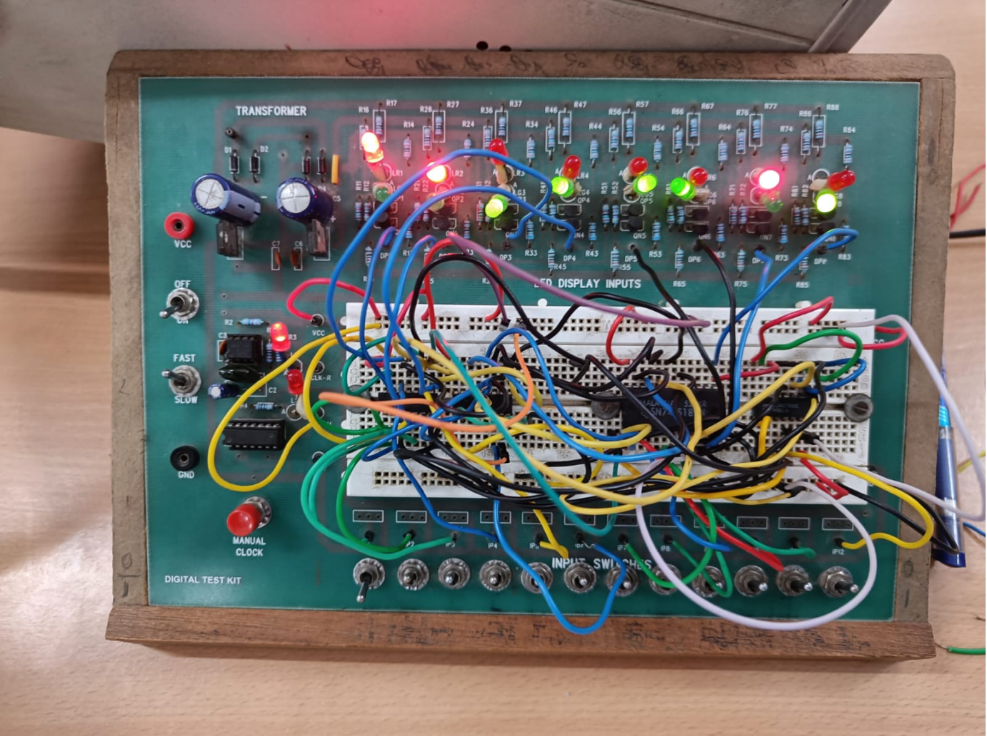

Reference circuit:-

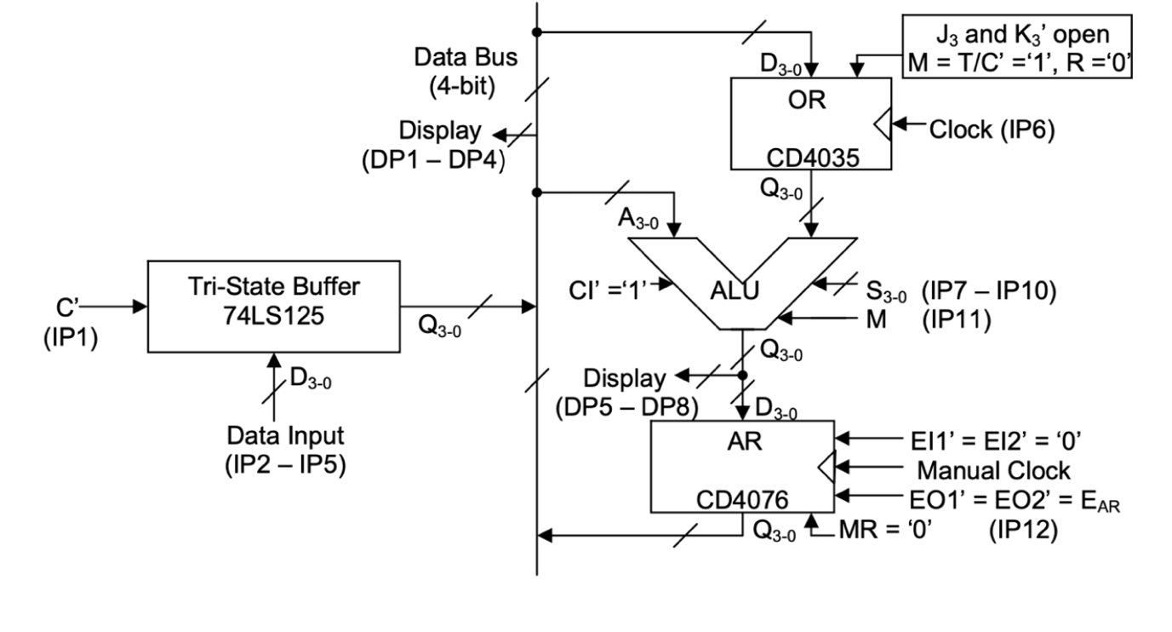

**Procedure**

1. Assemble the Tri State Buffer circuit on the left side of the vertical Data Bus. The four horizontal bus strips available on the breadboard will be used as the four lines of the Data Bus, in the order 3-2-1-0 from top to bottom.
2. The CD4035 serial/parallel shift register will be used (with M = 1) as the Operand Register (OR) in this experiment. The CD4076, a 4-bit register with separate 2-bit controls for input and output, will be used as the Accumulator (AR) to store the ALU output after every ALU operation.

For all the chips, Q3-0 denotes the 4-bit data output. For the registers (OR and AR) and the TSB, D3-0 denotes the 4-bit data input, while A3-0 and B3-0 denote the two 4-bit data inputs applied to the ALU.

1. Make C’(IP-1) = 1 and note that all the LEDs in DP1-DP4 are OFF, indicating that the bus is “floating”, i.e., not “driven” to a proper logic level by a digital output.
2. Enable the TSB output by making C’ = 0 and apply different data inputs through IP2- IP5 to verify that DP1-DP4 correctly display the applied input.
3. Complete the interconnections to the OR and the ALU. Transfer a suitable 4-bit number from IP2-IP5 to OR by enabling TSB output (C’ = 0) and applying a Clock pulse to OR through IP6.
4. Apply another 4-bit number from IP2-IP5 to the Bus and select an ALU function by applying the appropriate ALU control inputs S3-0 and M through IP7-IP11, keeping C’ LOW.
5. Verify that the 4-bit number displayed on DP5-DP8 does give the correct ALU output corresponding to inputs A3-0 coming from the Bus and B3-0 coming from OR. Complete the interconnections to the AR.
6. Transfer a suitable 4-bit number from IP2-IP5 to OR and apply another 4-bit number from IP2-IP5 to the Bus as done in step 5, keeping C’ LOW and EAR’ HIGH.
   1. Choose a suitable ALU function and note the ALU output displayed on DP5-DP8, as done in step 6.
   2. Apply a Manual Clock pulse to AR, causing the ALU output to be loaded in AR.
   3. Now disable the TSB output and enable the AR output by making C’ HIGH first and then EAR’ LOW.
7. Tabulate the results and verify the values displayed at each step theoretically ..

Observation:-

On performing a sequence of 3-4 suitably chosen ALU operations (from the function table of ALU) with the same number in OR, we observe the complete sequence of ALU outputs shown by DP5-DP8 is same as AR outputs shown by DP1- DP4.

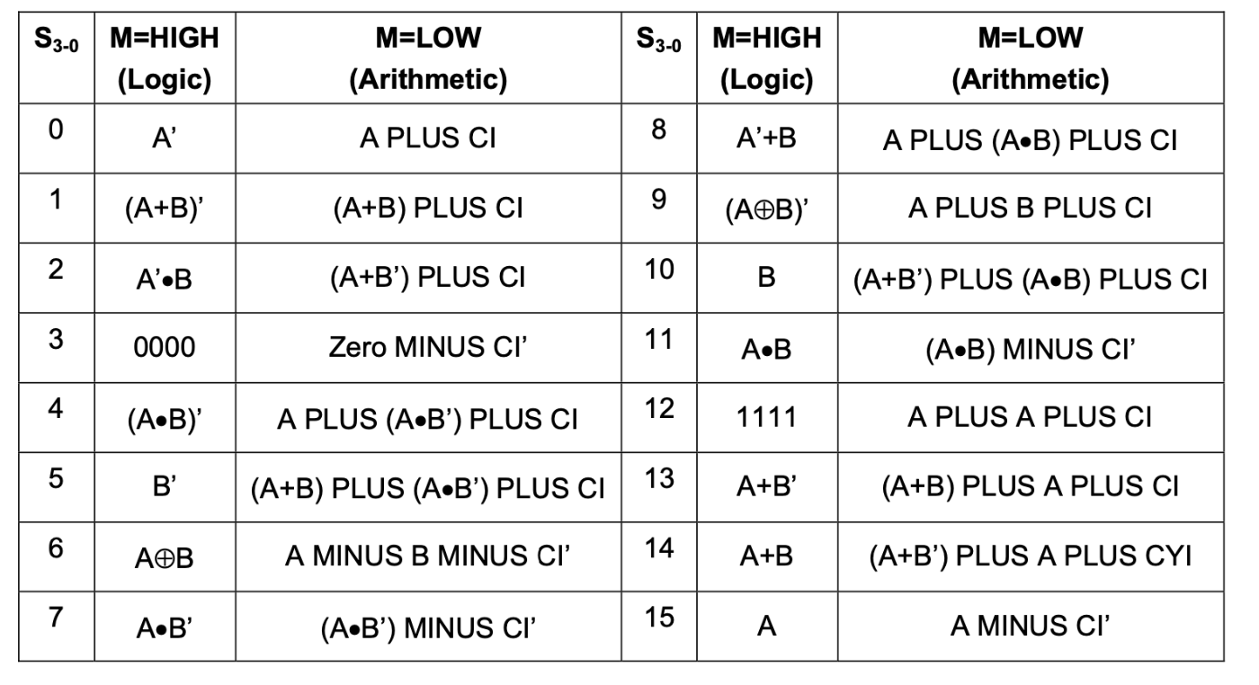

Conclusion:-

We have assembled and tested our simple bus based digital system(Programable ALU) and is ready to use..